ATL Take-Up System Identification

Owen Lu

Electroimpact Inc.

owenl@electroimpact.com

*Abstract*— It is proposed that on the new ATL heads that the dancer system is removed and replaced with a servo control loop that applies torque in order to reach steady-state tension in the web. In order to accurately calculate the tension in the web, a system identification must be conducted to understand the frictional and inertial characteristics in the system.

# Introduction

The core assumption of this system identification method is that friction behaves as the sum of Coulomb and viscous friction. Using first principles, a Laplace domain model is easily formulated for the mechanical system. The problem of system identification, in this case, will be solved using least-squares in the time domain after conducting experiments to approximate Coulomb and viscous friction.

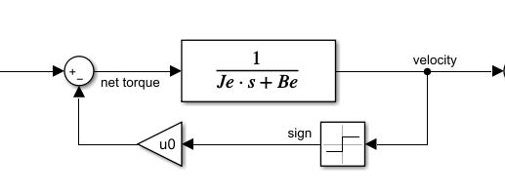

Figure 1 – Laplace domain model of the mechanical system

# Model

The model of the system is derived from a sum of torques on the reflected inertia .

|  |  |  |
| --- | --- | --- |
|  |  | () |

Where:

is the motor torque

$T_{d}$ is the disturbance torque modeled by Coulomb friction

$T_{v}$ is the viscous friction torque

$J_{e}$ is the reflection inertia

$α$ is the angular acceleration of the input shaft

Furthermore, the friction functions can be written in terms of $ω$ the angular velocity. Therefore, we can rewrite Eq. 1 shown in Eq 4.

|  |  |  |
| --- | --- | --- |
|  |  | () |
|  |  | () |
|  |  | () |

At this point, it is clear that the Laplace transform of the system results in the block diagram shown in Figure 1.

|  |  |  |
| --- | --- | --- |
|  |  | () |
|  |  | () |

# Algorithm

The first thing to note is that there are many different servo controller systems and software. Sometimes there are built-in functions to measure frequency response and even identify plant models and friction characteristics. Therefore, if there is a built-in tool that can reliably calculate the parameters $J_{e},B_{e},u_{0}$ this section can be skipped.

In this algorithm, it is assumed that Coulomb friction can be approximated via experiment and taken at face value. Assuming that estimates of $J_{e},B_{e}$ are also present from experiment or estimations these are the seed values. Afterward, the quantities $J_{e},B_{e}$ are optimized via a least-squares algorithm in the time domain.

The algorithm assumes that the following signals can be measured:

$T_{m}\left(t\right)$ the torque sent via the amplifier

$α(t)$ the angular acceleration of the input shaft

$ω\left(t\right)$ the angular velocity of the input shaft

Method:

1. Calculate $T_{d}\left(t\right)$ using Eq. 2
2. Calculate $T_{v}(t)$ using Eq. 3

Using Eq 4. we can rearrange for $α\left(t\right)$

|  |  |  |
| --- | --- | --- |
|  | $$α=\frac{T_{m}-u_{0}sign\left(ω\right)-B_{e}ω}{J_{e}}$$ | (7) |

For clarity, the $α$ vector calculated in Eq. 7 will be called $α_{m}$ since it is calculated from a model approximation.

Ideally, we expect $α_{m}$ and $α$ to be equal so least squares is used to reduce the sum of squared errors with respect to $J_{e},B_{e}$. In this case, the Gauss-Newton (GN) algorithm is used.

|  |  |  |
| --- | --- | --- |
|  | $${r\left(J_{e},B_{e}\right)}_{i}=α_{i}-{α_{m}}_{i}$$ | (8) |
|  | $$H_{i1}=\frac{∂r_{i}\left(J_{e},B_{e}\right)}{∂J_{e}}$$ | (9) |
|  | $$H_{i2}=\frac{∂r_{i}\left(J_{e},B_{e}\right)}{∂B_{e}}$$ | (10) |
|  | $$β={\left[\begin{matrix}J_{e} & B_{e}\end{matrix}\right]}^{T}$$ | (11) |
|  | $$β_{k+1}=β_{k}-inv\left(H^{T}H\right)H^{T}r(β_{k})$$ | (12) |

It is important to note that in the time domain data there is likely to be a significant number of outliers. Thus, the following procedure is suggested:

1. Send multiple cycles of a torque square wave to the plant
2. Using an initial estimate of $J_{e}$, $B_{e}$, $μ_{0}$ use GN to solve $J_{e},B_{e}$
3. Using RANSAC linear fit find the inliers of the system using vectors $α,α_{m}$
4. Filtering by only inlier data, re-compute $J_{e},B_{e}$ using Gauss-Newton

This method was verified in simulation to produce good results but needs real data for further vetting.

# General Experimental Procedure

Since the parameters of the system are unknown in terms of operating points, a general guideline is provided.

Friction Experiment

1. Tune the system so that steady-state commanded velocity can be reached
2. Send velocity commands and record steady-state torque
3. Use logarithmically spaced velocity commands so that higher resolution is near 0 velocity.

Inertia Experiment

1. Send a torque square wave to the system
2. Measure $T_{m},α,ω$ at the motor shaft
3. Ensure that the square wave frequency results in a saw-tooth response of velocity.

At this point using the collected data, initialize $J_{e},B_{e},u_{0}$ and solve the least-squares.

# Simulation Verification

Although no experimental data was provided thus far, simulation combined with random noise can be used for an initial benchmark. The model was recreated and the noise was added as a disturbance to the velocity signal. The algorithm was successful in identifying $J_{e},B_{e}$ within 5% given a 5% error of shaft velocity.

Figure 2 shows the RANSAC linear fit after the first GN optimization. Clearly, the outliers have little effect on the linear estimate. Outliers are then removed from the final data set used for optimization. In Figure 3, we see an estimation of the angular acceleration from the model compared to the raw input signal. Clearly we see that despite the noise, a good mean estimate of the signal is obtained. At this point, net torque due to frictional and inertia effects can be estimated. It is then assumed that deviations from this mean signal in operation would be due to torque from tension.

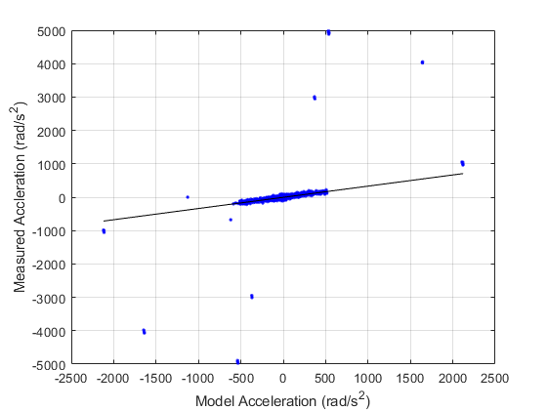

Figure - RANSAC linear fit

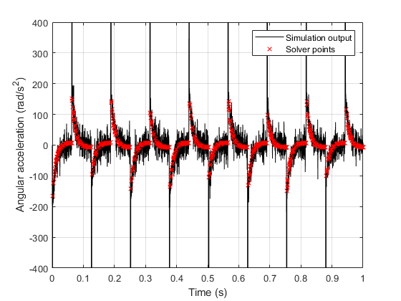

Figure - Time domain model estimation